Getting esp32 devkit ready for Arduino ide

Installing Arduino IDE

Go to the [Arduino website and download the version](https://www.arduino.cc/en/software#experimental-software) for your operating system.

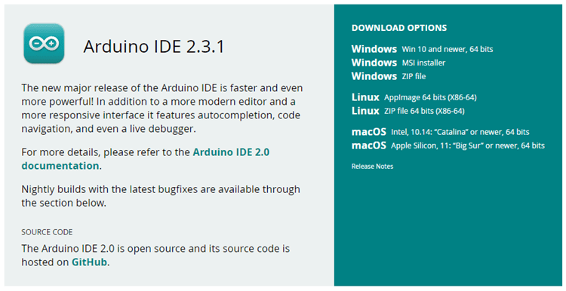

* **Windows**: run the file downloaded and follow the instructions in the installation guide.
* **Mac OS X**: copy the downloaded file into your application folder.
* **Linux**: extract the downloaded file, and open the arduino-ide file that will launch the IDE.

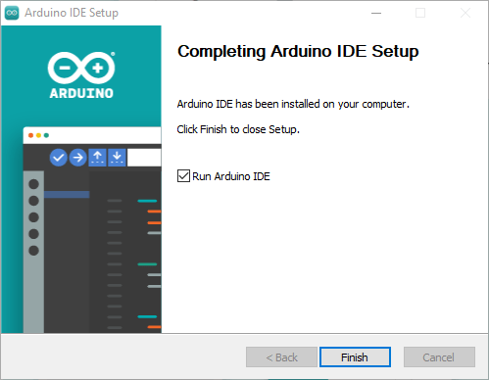

**Install ESP32 Add-on in Arduino IDE**

To install the ESP32 board in your Arduino IDE, follow these next instructions:

**1.**In your Arduino IDE 2, go to **File**> **Preferences**.

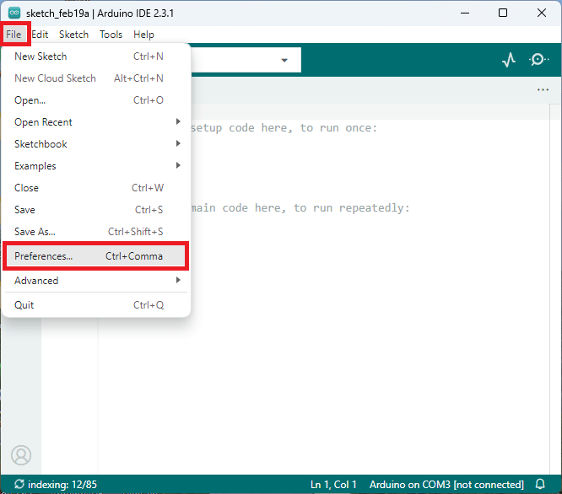

**2.** Copy and paste the following line to the **Additional Boards Manager** URLs field.

https://raw.githubusercontent.com/espressif/arduino-esp32/gh-pages/package_esp32_index.json

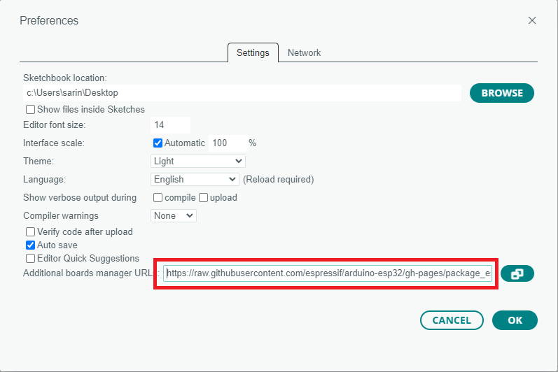

**Note:** if you already have the ESP8266 boards URL, you can separate the URLs with a comma, as follows:

http://arduino.esp8266.com/stable/package_esp8266com_index.json, https://raw.githubusercontent.com/espressif/arduino-esp32/gh-pages/package_esp32_index.json

3. Open the Boards Manager. You can go to **Tools**> **Board**> **Boards Manager…** or you can simply click the **Boards Manager**icon in the left-side corner.

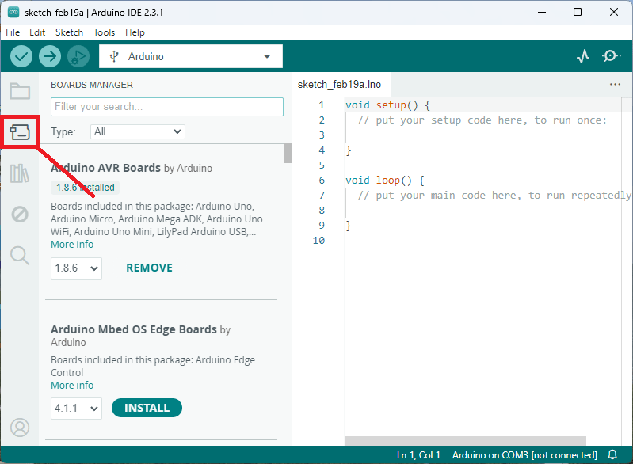

4. Search for **ESP32**and press the install button for **esp32 by Espressif Systems version 3.X**.

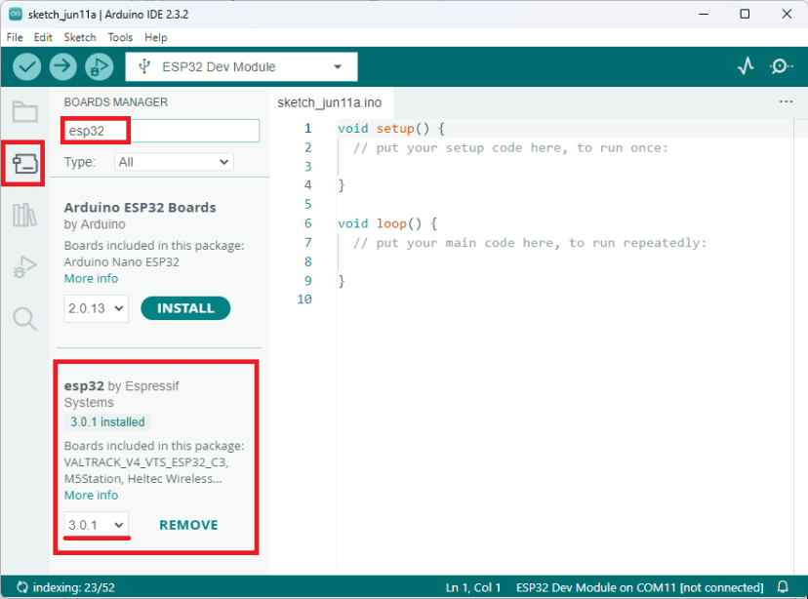

That’s it. It should be installed after a few seconds.

**Testing the Installation**

To test the ESP32 add-on installation, we’ll upload a simple code that blinks the on-board LED (GPIO 2).

#include <Arduino.h>

#define LED 2

void setup() {

// put your setup code here, to run once:

Serial.begin(115200);

pinMode(LED, OUTPUT);

}

void loop() {

// put your main code here, to run repeatedly:

digitalWrite(LED, HIGH);

Serial.println("LED is on");

delay(1000);

digitalWrite(LED, LOW);

Serial.println("LED is off");

delay(1000);

}

**Uploading the Sketch**

Select your board before uploading the code. On the top drop-down menu, click on “**Select other board and port…**“

[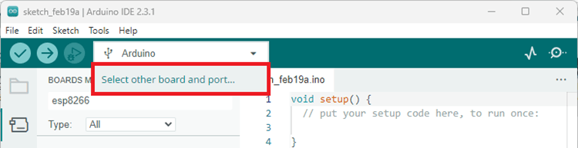](https://i0.wp.com/randomnerdtutorials.com/wp-content/uploads/2024/02/arduino-ide-2-select-board.png?quality=100&strip=all&ssl=1)

A new window, as shown below, will open. Search for your ESP32 board model.

[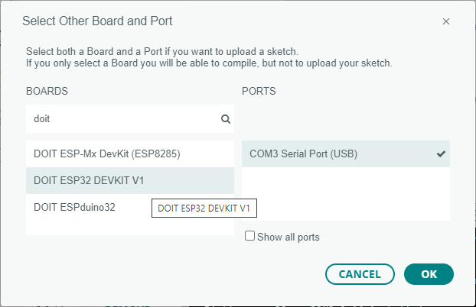](https://i0.wp.com/randomnerdtutorials.com/wp-content/uploads/2021/05/arduino-ide-2-select-board-esp32.png?quality=100&strip=all&ssl=1)

Select the ESP32 board model you’re using, and the COM port. In our example, we’re using the DOIT ESP32 DEVKIT V1. Click **OK** when you’re done.

Now, you just need to click on the **Upload**button.

Arduino IDE 2 Upload Button

After a few seconds, the upload should be complete.

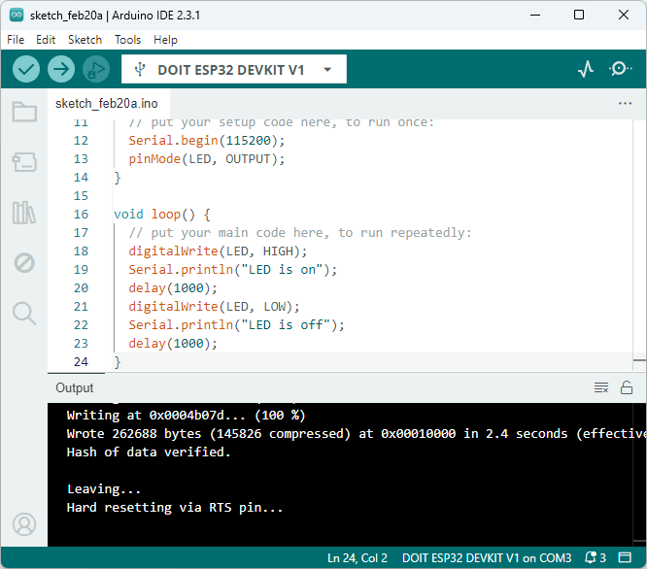

**Note**: some ESP32 development boards don’t go into flashing/uploading mode automatically when uploading a new code and you’ll see a lot of dots on the debugging window followed by an error message. If that’s the case, you need to press the ESP32 BOOT button when you start seeing the dots on the debugging window.

The ESP32 on-board LED should be blinking every second.

[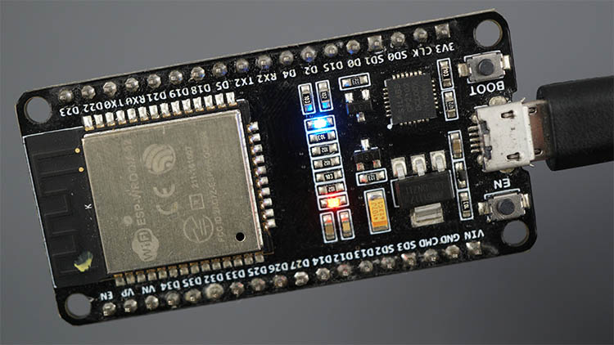](https://i0.wp.com/randomnerdtutorials.com/wp-content/uploads/2020/04/ESP32-board-Built_in-LED-turned-on-HIGH.jpg?quality=100&strip=all&ssl=1)

**Serial Monitor**

You can click on the Serial Monitor icon to open the Serial Monitor tab. Make sure you select the 115200 baud rate.

